Flow fields

# Types of fields (3 types)

## Cost field

* Hold cost-to
* Used as input for building the flow field
* 8-bit field
* Possible value 0-255
  + 255 is wall
  + 1-254 traversable
* Minimum cost is 1

## Integration field

* 24-bit field
* First 16 bits -> Total integrated cost
* Second 8 bits -> used for integration flags
* Optionally spend more memory bot better flow results (eg: 32-bit float integrated cost)

## Flow field

* 8-bit fields
* First 4 bits -> index into direction lookup table
* Second 4 bits -> flags

# Implementation

## Step 1: Generate Cost-field

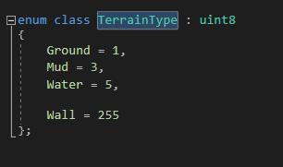It’s not necessary to generate an extra cost field, since all the nodes contain the cost to travel to them.

Currently there are 4 types of terrain:

* Ground (cost =1)
* Mud (cost = 3)
* Water (cost = 5)
* Wall (cost = 255)

The cost/terrain is stored in a uint8, since we don’t need more numbers for the scale of this demo. If more would be needed, it would be as easy as using a larger size integer or even a float.

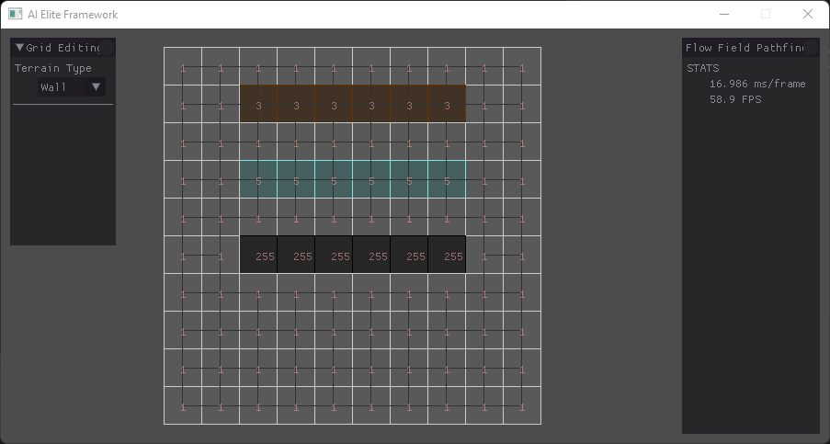This is how the ‘Cost-field” looks with debug rendering.

## Step 2: Generate integration field

The integration field assigns new costs to each cell. The target cell always has a cost of 0. Starting from this cell, we check every other cell. For every cell, we check the neighbors and remember the lowest neighboring score. We add this score with the cost field score of the current cell and this is our final cost.

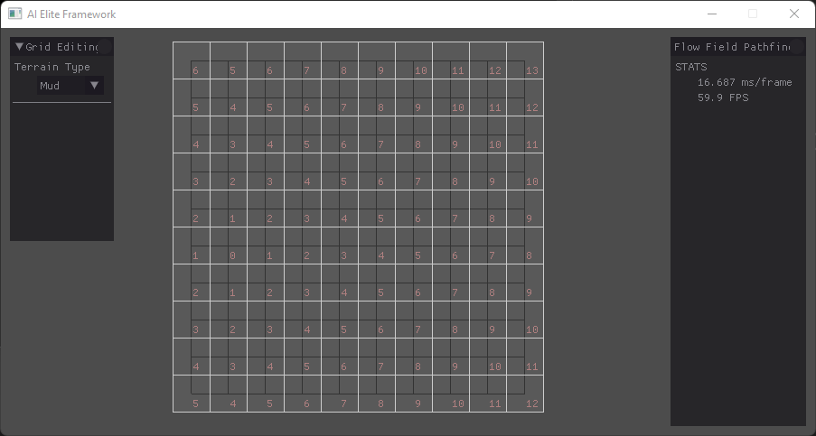

This is how the integration field looks, without different type of terrain.

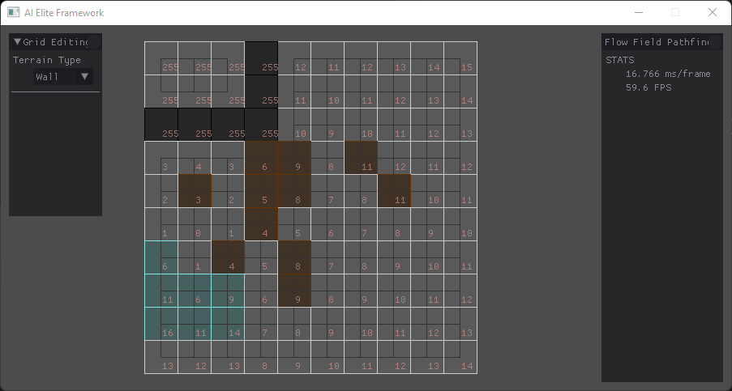This is how the integration field looks, with different type of terrain.

This demo does not have any flags implemented/used.

## Step 3: Generate directions

The direction map/flow field contains all the direction that should be followed by the agents. This is calculated by checking all neighbors of every cell and calculating the direction from the current cell to the neighbor with the lowest integration cost.

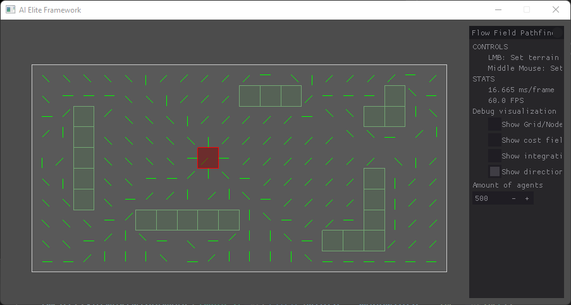This is how a generated flow field looks.

## Step 4: Steering

Agent steering is rather easy to implement. In the steering behavior we check in which cell the agent resides. We set the steering velocity to the direction of the cell and scale it to the agent speed.



## Step 5: Flocking

To make the steering look more natural, we can add flocking to the agents. This way the agents react to each other. The flocking behavior consists of:

### A picture containing text Description automatically generatedSeparation

The agents move away from neighboring agents.

### 

### Cohesion

The agents move towards neighboring agents.

### Velocity match

The agents match their velocity to neighboring agents’ velocity.

### Wander

The agents randomly wander the world.

### Obstacle evasion

The agents try to move away from obstacles, to prevent collision.

## Step 6: Putting it all together

With everything combined, we have a cheap and efficient alternative to using cost-heavy pathfinding like A* on every agent. This is how the result looks.



## Resources

Li, H and Hamilton, H. (2015), Crowds - Flow Fields, URegina, accessed 05/01/2022, <http://www2.cs.uregina.ca/~anima/408/Notes/Crowds/FlowField.pdf>

Treuille, A , Cooper, S and Popovic´, Z. (n.a.), Continuum Crowds, Washington.edu, accessed 05/01/2022, < <http://grail.cs.washington.edu/projects/crowd-flows/continuum-crowds.pdf>>

Turbo Makes Games. (2020), How flow field pathfinding works – flow fields in unity ep.1, youtube, accessed 05/01/2022, < <https://www.youtube.com/watch?v=zr6ObNVgytk>>

Emerson, E. (2013). Crowd Pathfinding and Steering Using Flow Field Tiles. In S. Rabin (Ed.), *Game AI Pro: Collected Wisdom of Game AI Professionals* (pp. 307-316). Boca Raton: CRC Press.

Renee Jansen, M and R. Sturtevant, N. (october 2008), Direction maps for cooperative pathfinding, accessed 05/01/2022, < https://www.aaai.org/Papers/AIIDE/2008/AIIDE08-031.pdf>